**RESOLUTION:**

BOOKING.JAVA

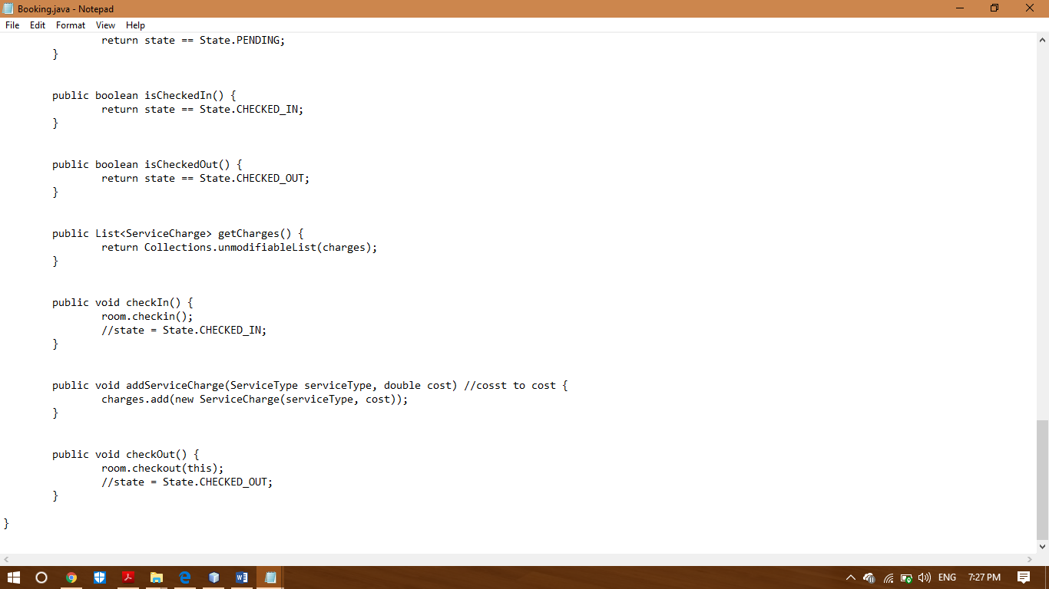

The above screenshot is the corrected code for booking.java the correction is shown in the comments.

ROOM.JAVA

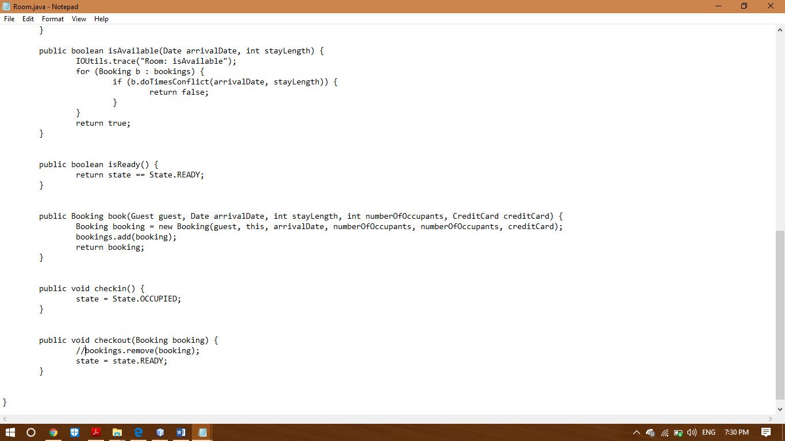

The above screenshot is the corrected code for room.java the correction is shown in the comments.

HOTEL.JAVA

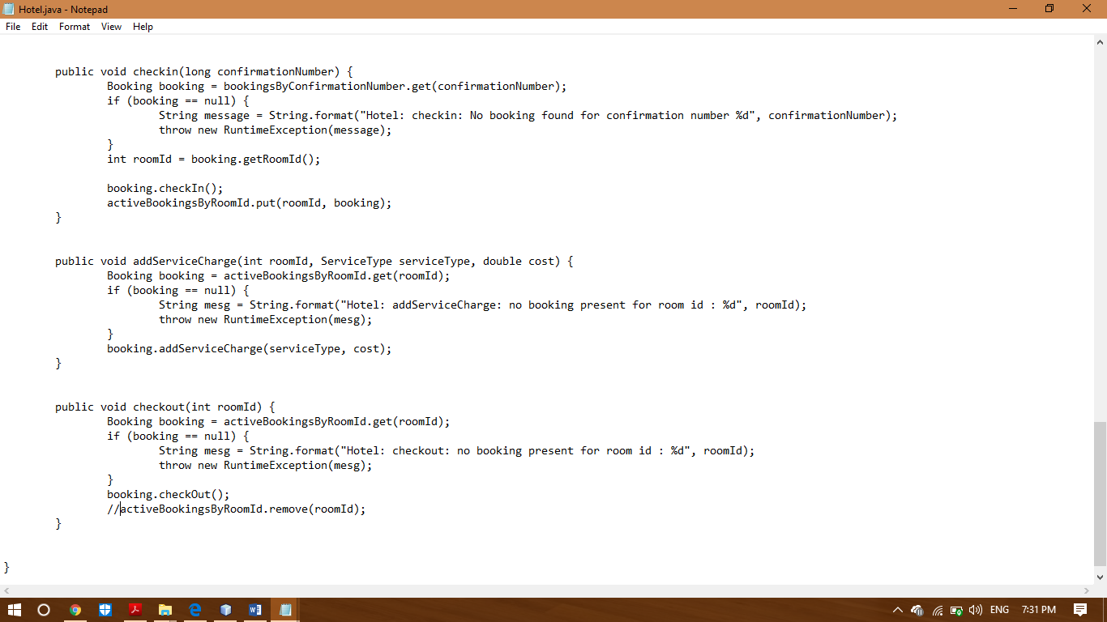

The above screenshot is the corrected code for hotel.java the correction is shown in the comments.

**RESOLUTION OUTPUTS:**

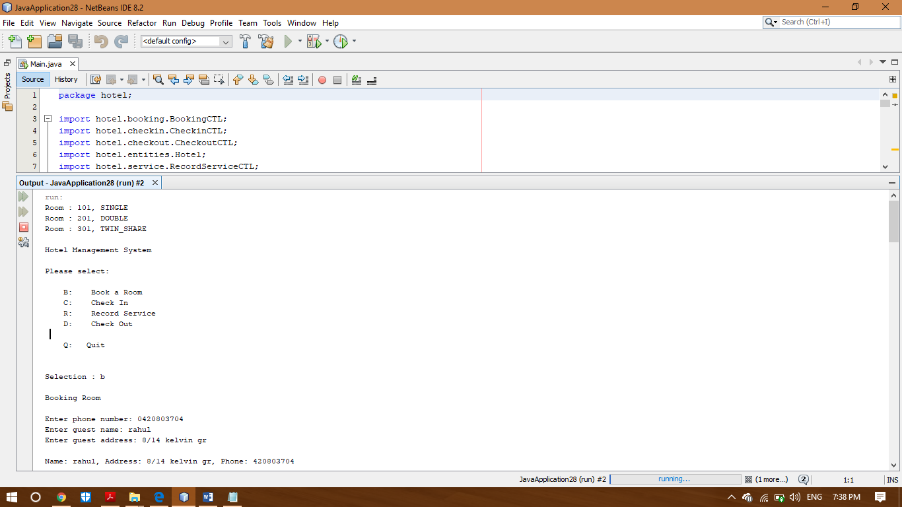

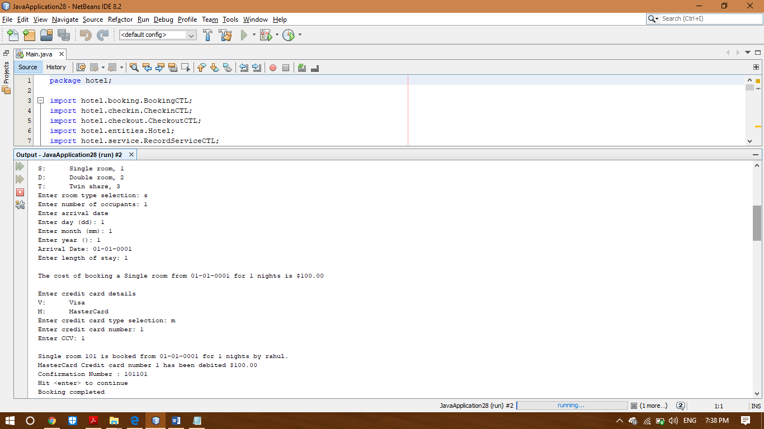

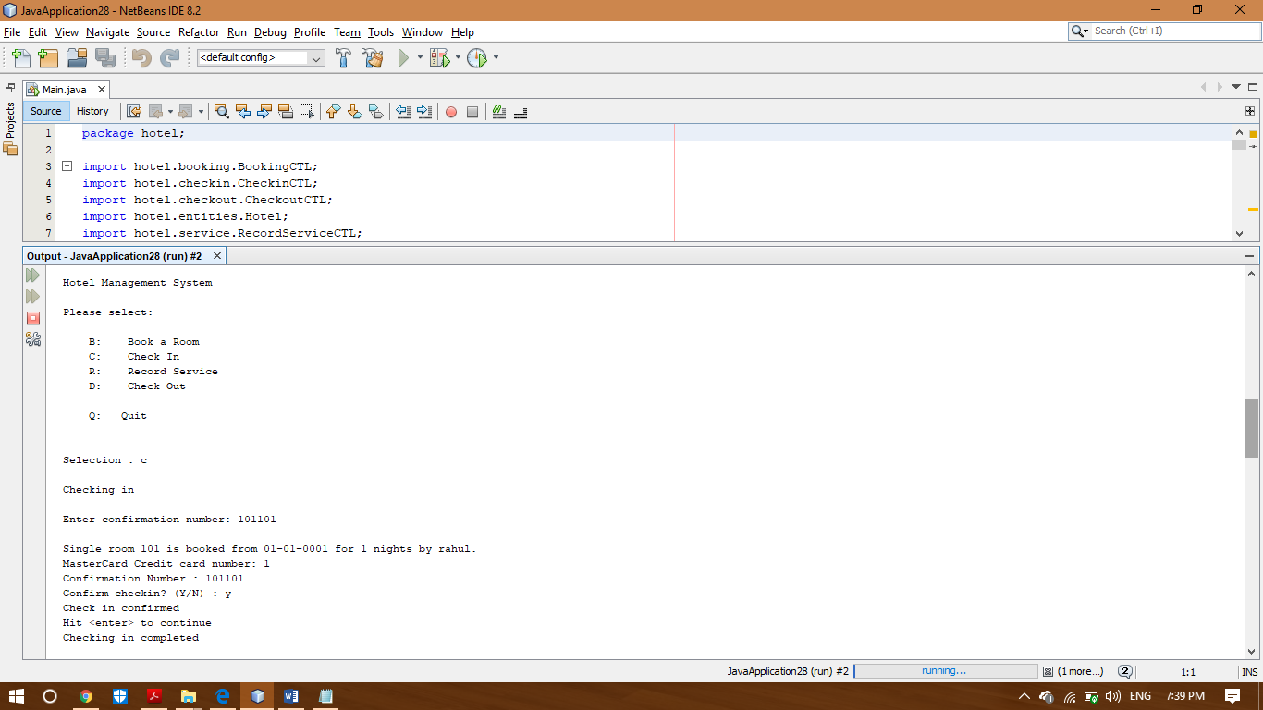

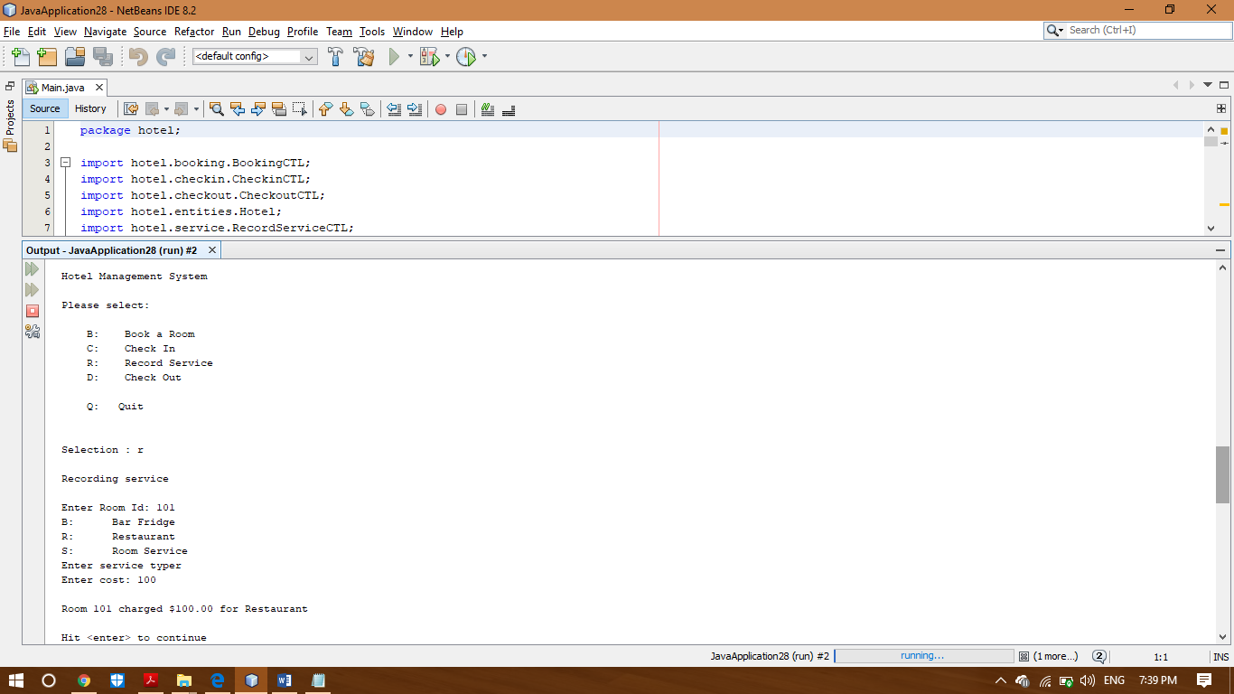

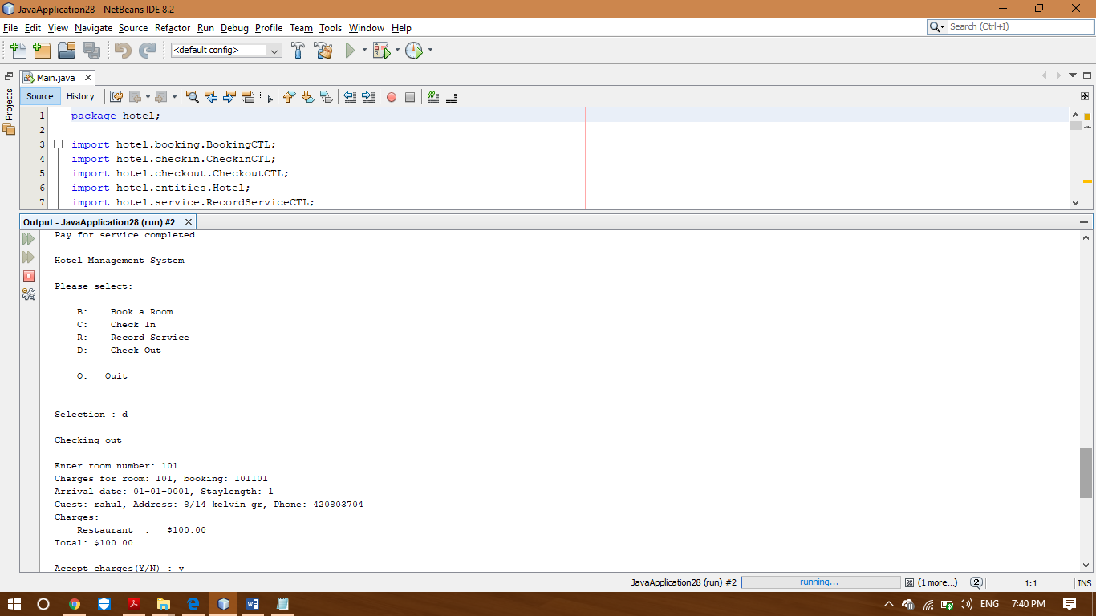

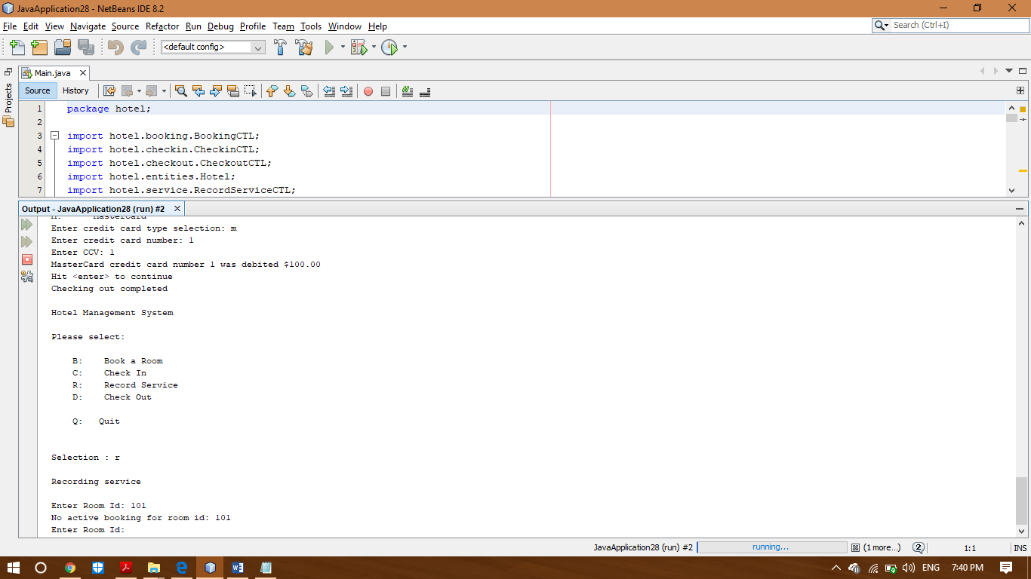

The above screenshots are the output of corrected code.